**Cive497: Assignment 7**

**Geosolver Matlab Project**

**Tunnel Design Analysis Test Case**

(Input file name: TunnelExample.txt)

A tunnel is designed at a depth of 30m below the ground surface, with a smaller servicing tunnel beside to the right. Geometry and material properties are as shown below:

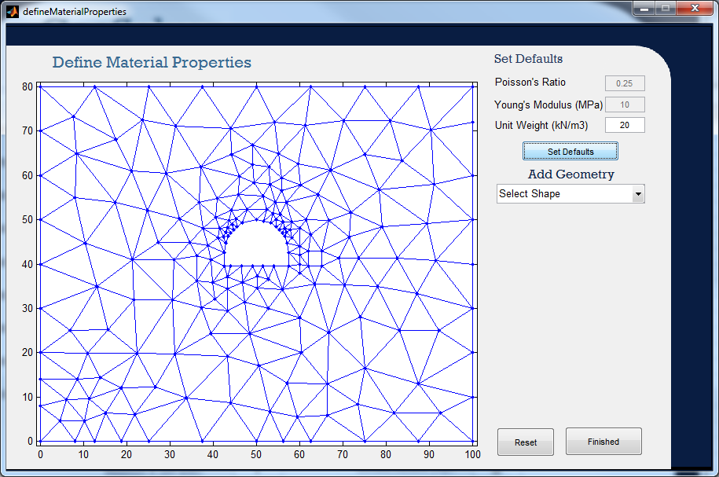

Boundary Conditions are as follows:

* Bottom boundary restrained in y-direction
* Vertical side boundaries restrained in x-direction
* Both bottom corners restrained in x- and y-direction

The resultant stress, strain, and displacement concentrations and trajectories around the tunnel are shown in the figures below, as well as verification plots from Rocscience’s Phase2 FEM software. Individual elemental stresses and strains as well as nodal forces and displacements can be viewed in Matlab. Refer to the *Data Structures* section of the *User Manual.docx* (attached) for a guide as to the names of the vectors and matrices which store these data.

Sigma 1: (Geosolver)

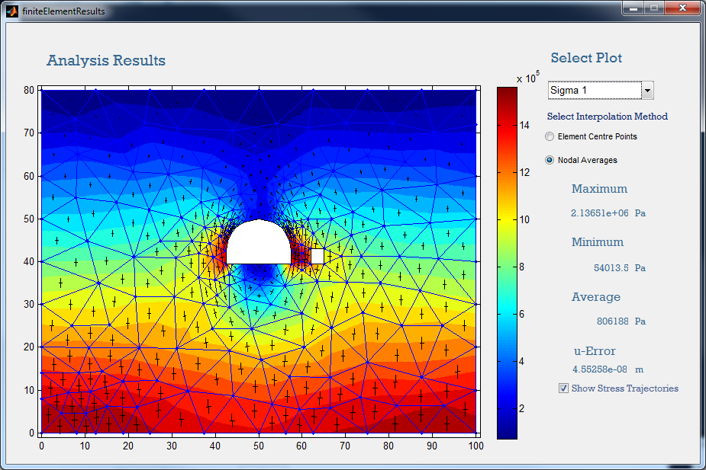

Sigma 1: (Rocscience Phase2 Verification)

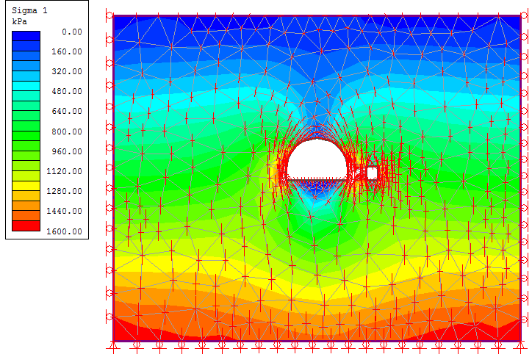

Sigma 3: (Geosolver)

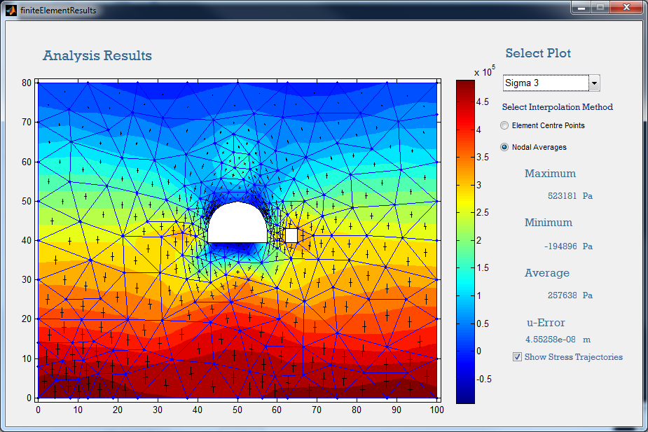

Sigma 3: (Rocscience Phase2 Verification)

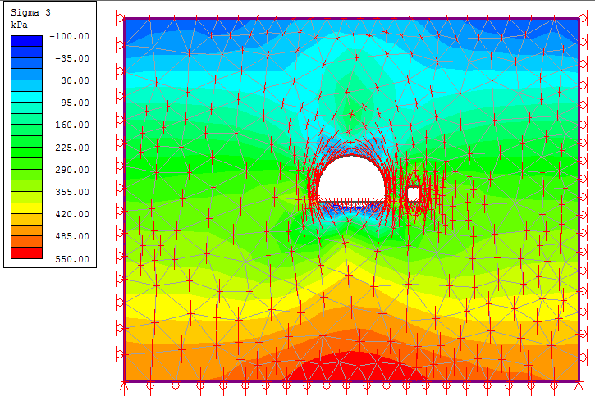

Tau XY: (Geosolver)

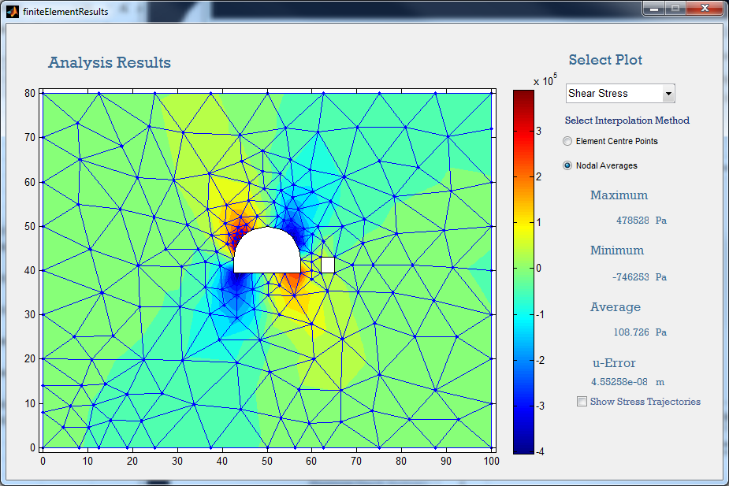

Tau XY: (Rocscience Phase2 Verification) (units kPa)

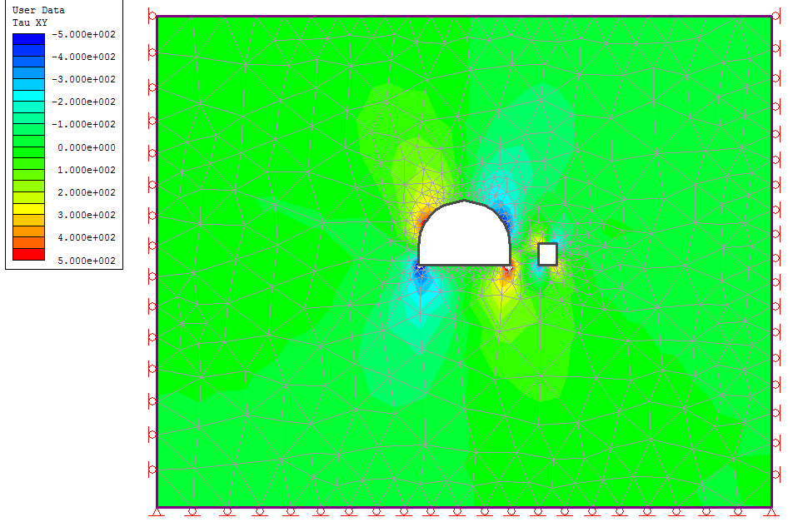

Displacement: (Geosolver)

Maximum y-displacement: -5.66m

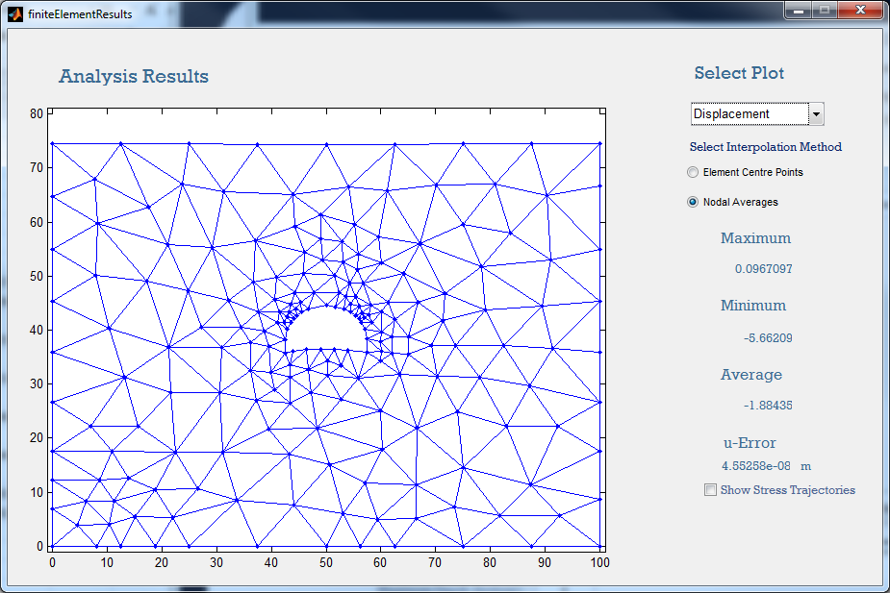

Y-Strain: (Geosolver)

